HJJDS6031

Parameter description: 2
Appearance 3
Introduction to Interface Display 4
Key 5
Operation introduction 6
Press down CH: 6
Press down PARM: 7
Press down TRIG: 7
First press down HORI: 8
Second press down HORI: 8
First press down MENU: 9
Second press down MENU: 9
Third press down MENU: 10
Fourth press down MENU: 11
Fifth press down MENU: 11

Parameter description:

Channel: 1
Bandwidth: 30MHz
real-time sampling rate 200MSa/s
The storage depth 2Kpts
Input coupling AC、DC
Input impedance 1MΩ 25pF
The maximum input voltage 40V (probe X1); 400V (probe X10) can be measured 220V
voltage; (probe X100) 2000V voltage can be measured
Probe attenuation 1X、10X
Set the probe attenuation factor 1X、10X、100X
Sampling Method Real-time sampling(10ns-50ms)/Scan sampling(100ms-5s)
Vertical Sensitivity 10mV-5V (Probe 1X) 100mV-50V (probe 10X) (1,2.5,5 step)
Vertical accuracy +/-3%
Vertical resolution 8bit
Horizontal scan range 10nS/div-5S/div(1,2.5,5 step)
Trigger Mode Auto, Normal and Single
Trigger Type Rising edge trigger, falling edge trigger
Automatic detection Support (50Hz-40MHz)
Cursor measurements Support time and voltage cursors
Screen 3.2-inch, 16-bit true color, TFT, 320 * 240
Battery 2800 + mA lithium battery (single cell about four Six of
continuous work)
Size 195 * 99* 39(mm)

Appearance

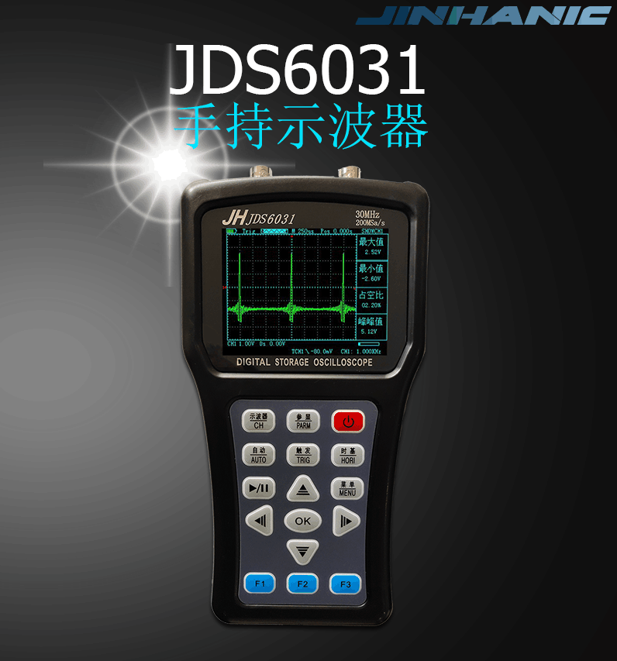

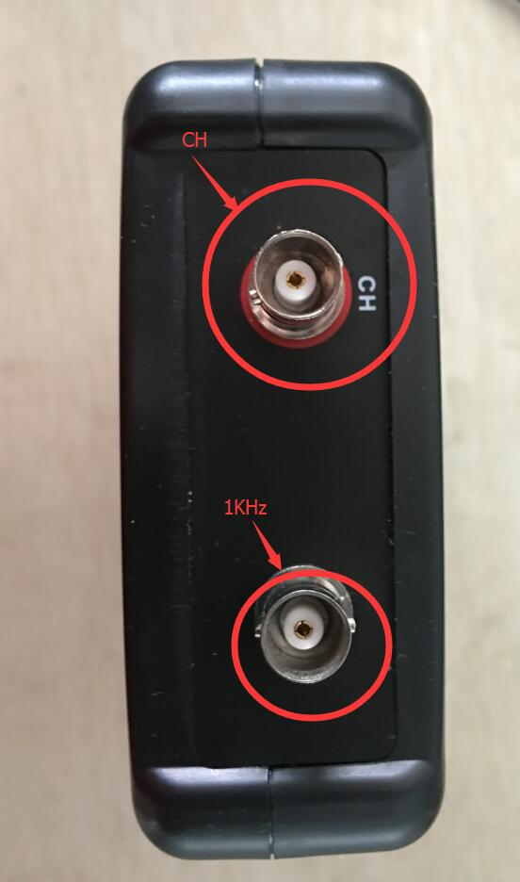

Introduction to Interface Display
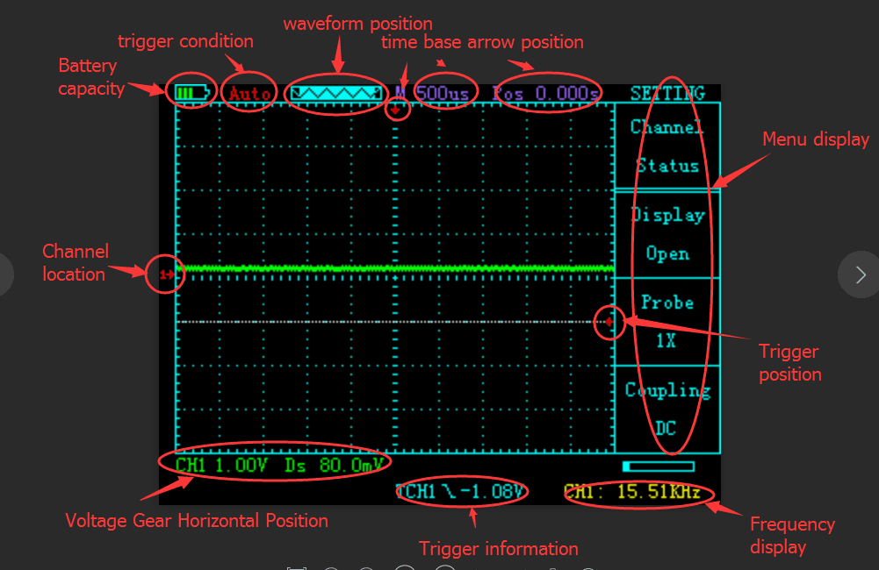

Key
Main buttons as follows

CH Access Channel Control
PARM Display parameters
Power Turn on and off
AUTO Automatic retrieval of waveforms
TRIG Trigger control
HORI Time-based correlation control
STOP/RUN Stop start waveform display
MENU Control menu
OK Under the corresponding menu Function key
↑ Under the corresponding menu Function key
↓ Under the corresponding menu Function key
← Under the corresponding menu Function key
→ Under the corresponding menu Function key

F1 Under the corresponding menu Function key
F2 Under the corresponding menu Function key
F3 Under the corresponding menu Function key

Operation introduction

Press down CH:
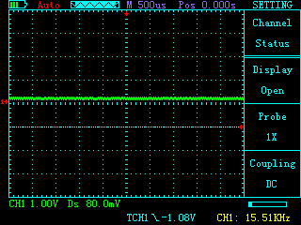
Function key description

↑ Voltage shift control
↓ Voltage shift control
← Waveform Horizontal Position Control
→ Waveform Horizontal Position Control
F1 Open Closed Channel Display
F2 probe x1,x10,x100
F3 AC and DC

Press down PARM:
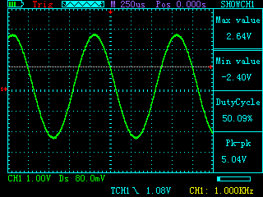
Function key description

↑ Voltage shift control
↓ Voltage shift control
← Waveform Horizontal Position Control
→ Waveform Horizontal Position Control
F1 Open Closed Channel Display
F2 probe x1,x10,x100
F3 AC and DC

Press down TRIG:
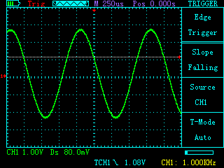
Function key description

↑ Trigger position shift
↓ Trigger position shift
← Trigger position shift
→ Trigger position shift
F1 Rising edge and falling edge trigger
F2 invalid
F3 Select trigger type automatically normal single

First press down HORI:
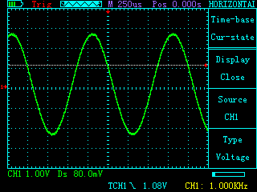
Function key description

↑ Changing time base
↓ Changing time base
← Change the position of the time base arrow
→ Change the position of the time base arrow
F1 Open and close measuring scale
F2 The object of scale measurement
F3 Type Voltage Time Measured by Scale

Second press down HORI:
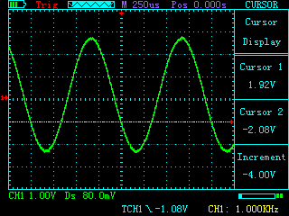
Function key description

↑ Position of scale 2 of the table
↓ Position of scale 2 of the table
← Position of scale 1 of the table
→ Position of scale 1 of the table
F1 invalid
F2 invalid
F3 invalid

First press down MENU:
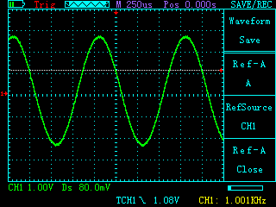
Function key description

↑ invalid
↓ invalid
← invalid
→ invalid
F1 Label of stored waveform A or B
F2 Source of stored waveform
F3 Whether to display stored waveforms

Second press down MENU:
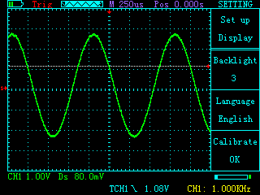
Function key description

↑ invalid
↓ invalid
← invalid
→ invalid
F1 Change the brightness level of backlight
F2 Language Selection of Interfaces
F3 Auto-calibration

Third press down MENU:
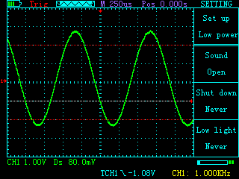
Function key description

↑ invalid
↓ invalid
← invalid
→ invalid
F1 Turn on and off button sound
F2 Turn on and off automatic shutdown
F3 Turn on and off automatic power saving

Fourth press down MENU:
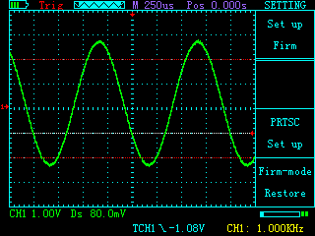
Function key description

↑ invalid
↓ invalid
← invalid
→ invalid
F1 invalid
F2 Setting up screenshots
F3 Factory Default

Fifth press down MENU:
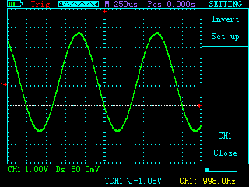
Function key description

↑ invalid
↓ invalid
← invalid
→ invalid
F1 invalid
F2 invalid
F3 Turn on the inversion of the closed waveform

OK Explain:
Used for screenshots when screenshots are turned on
Used to store waveforms when screenshots are turned off

