table of Contents
SMTO1004s Series Manual 2
1.Operation guide: 2
1.1 Operating area 2
1.2 Multi-point gesture operation 4
1.2.1 Two-point gesture operation 4
1.2.2 Three-point gesture operation 5
2. Interface description: 5
3. Oscilloscope instructions: 8
3.1 STOP key: 8
3.2 Trigger option key: 9
3.3 Time base button: 10
3.4 Oscilloscope-signal generator switch button 10
3.5menu: 11
3.5.1 Mathematical calculation 11
3.5.2 Ruler menu: 12
3.5.3 Parameter display: 12
3.5.4 Waveform comparison REF: 13
3.5.5 Function options: 14
3.6 C1 Channel menu 16
3.7 C2 Channel menu 16
3.8 C3 Channel menu 17
3.9 C4 Channel menu 17
4. Signal generator instructions: 17
5. Screenshot 17
6.Program upgrade 18
7.Oscilloscope parameters: 18
8.Signal generator parameters: 19
9. Accessories list: 19

SMTO1004s Series Manual

1.Operation guide:

1.1 Operating area
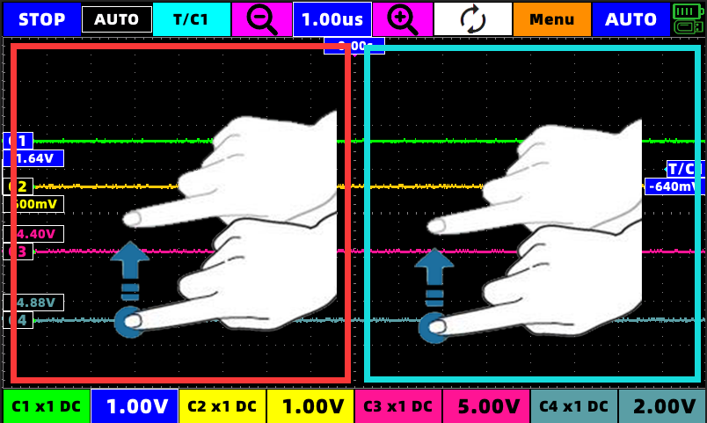

In the red area in the figure, slide up and down with a single finger, and the operability icon is C1,C2,C3,C4,V1
In the blue area in the figure, slide up and down with a single finger, and the operability icon is T/C1,V2
Select the icon you want to slide to turn it blue (active), and slide your finger up and down anywhere in the corresponding operation area to move the icon.
The icon will move with the speed of the finger.
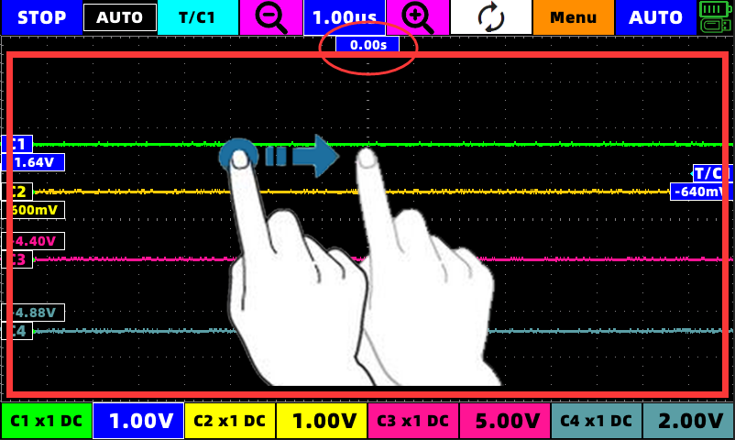

In the red area in the figure, slide left and right with a single finger, and the operability icon is T (the icon in the red circle) S1,S2
Select the icon you want to slide to turn it blue (active), and slide your finger up and down anywhere in the corresponding operation area to move the icon.
The icon will move with the speed of the finger.

1.2 Multi-point gesture operation
The machine supports 2-point gesture operation and 3-point touch screen capture.

1.2.1 Two-point gesture operation
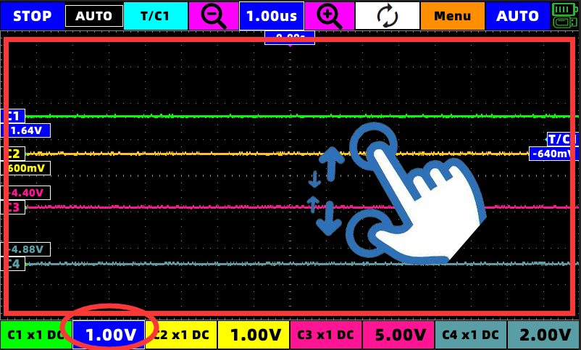
When the C1 or C2 or C3 or C4 channel is selected and the red circle turns blue, the two-point touch will take effect for that channel.
(Vertical) Two-point touch can change the magnification of the waveform (that is, change the voltage scale)

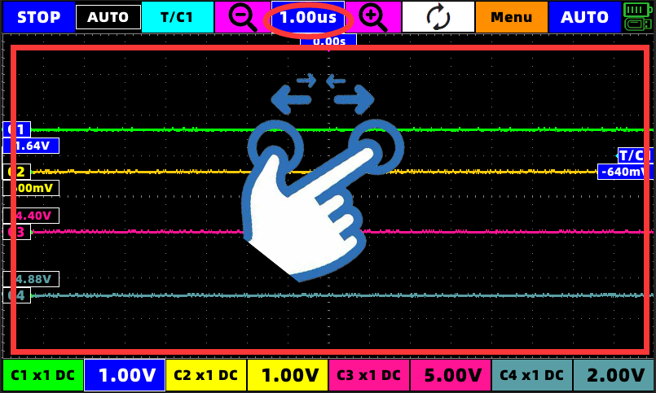

(Horizontal) Two-point touch can change the time base of the waveform (the value in the red circle in the figure)

1.2.2 Three-point gesture operation
After inserting the U disk, at any position on the screen, tap three fingers at the same time for 1 second after the buzzer sounds, a progress bar will appear, and the screenshot will be completed after the progress bar runs through the buzzer prompt.

Interface description:
Boot into the main interface:
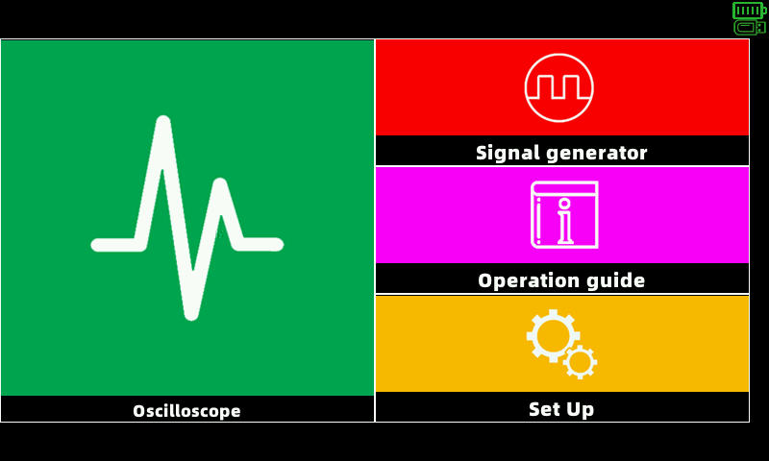
The main interface can choose oscilloscope, signal generator and setting interface.
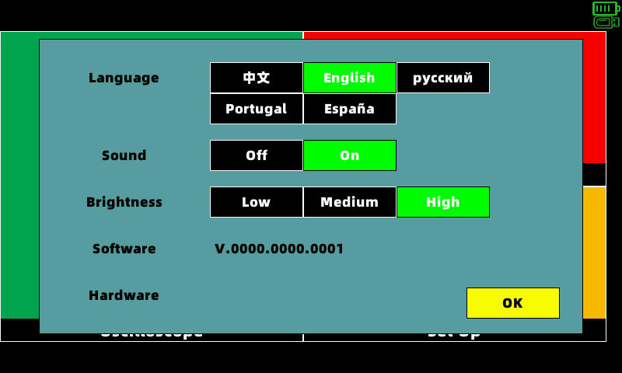
Click on settings to see
Language selection, sound switch, brightness adjustment and software and hardware version number. You can modify it as needed.
Click on the oscilloscope to enter the oscilloscope interface:
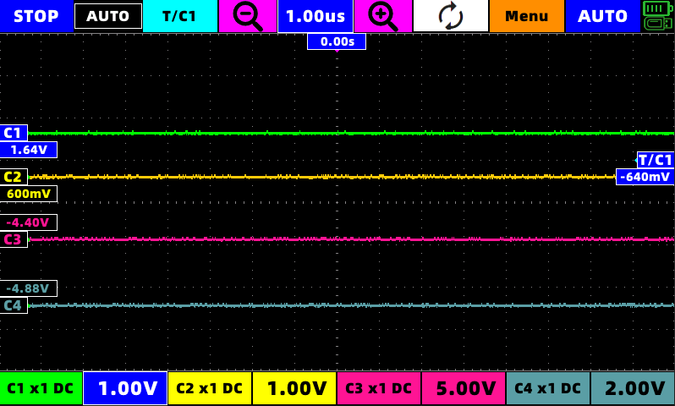
Click on the signal generator to enter the signal generator interface:
In the signal generator interface, if the red frame can switch the signal outputCH1,CH2.
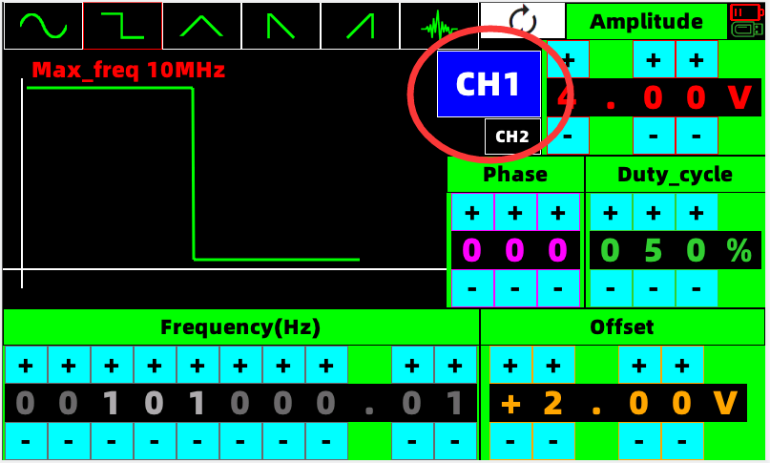
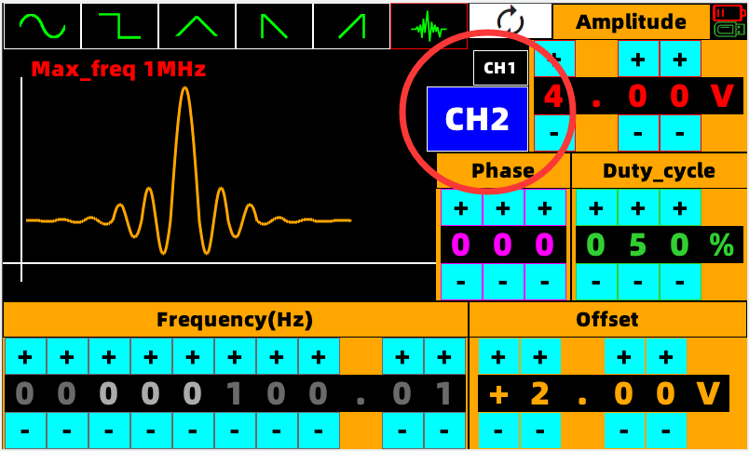

Oscilloscope instructions:

STOP key:
Press stop to stop the waveform, and the stopped waveform can be zoomed in and out to view the details. There is a small image of the original waveform in the upper left corner.
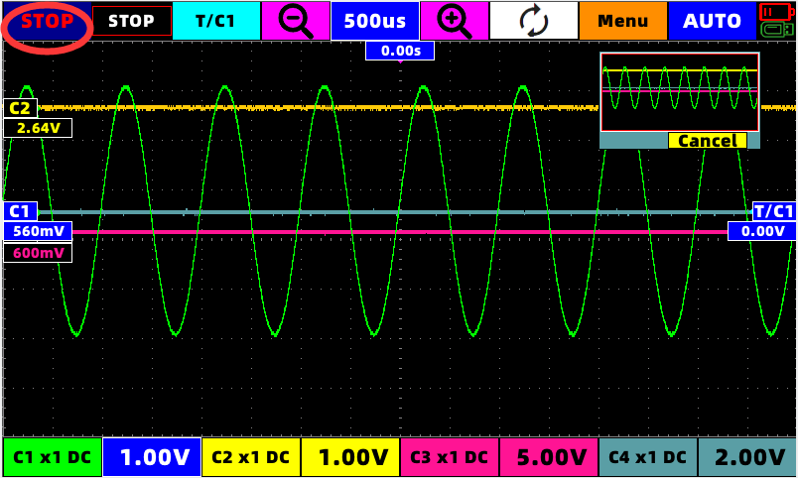

Trigger option key:
Click the red circle T/C1 button, and the trigger option will pop up
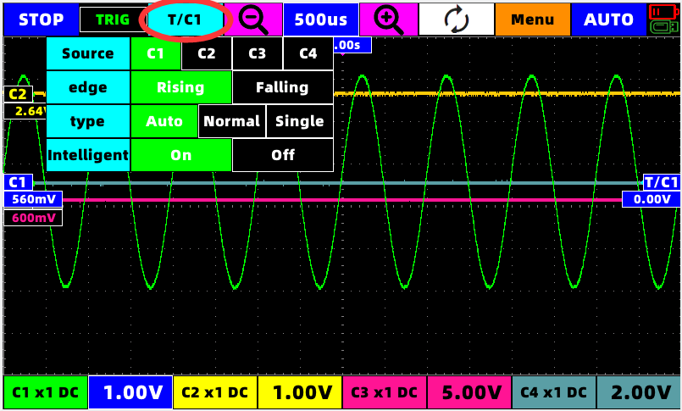
can choose
Signal source C1 or C2 or C3 or C4
Rising edge or falling edge
Auto trigger, normal trigger and single trigger
Smart trigger or manual trigger
Note: There is no need to manually adjust the trigger position of the waveform under smart trigger, the program will automatically find the appropriate trigger position and trigger the waveform.

Time base button:
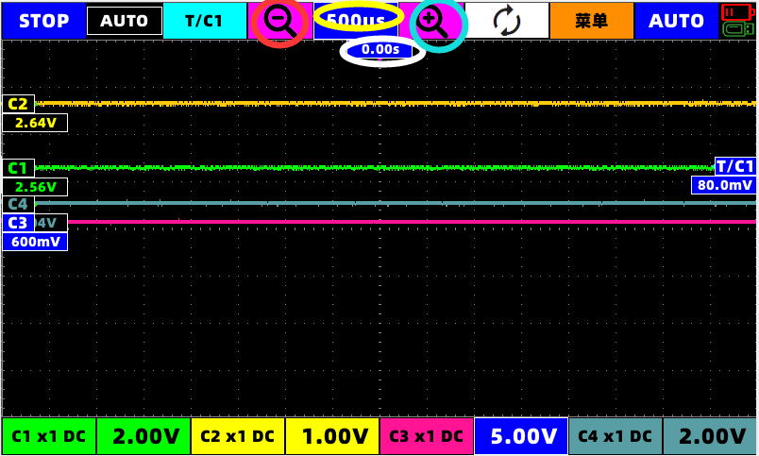
In the picture, the button in the red circle is to reduce the time base, and the button in the basket is to zoom in the time base,While the button in the yellow circle displays the current time base value, the time position (that is, the parameter in the white circle) can be returned to zero with one key.

Oscilloscope-signal generator switch button
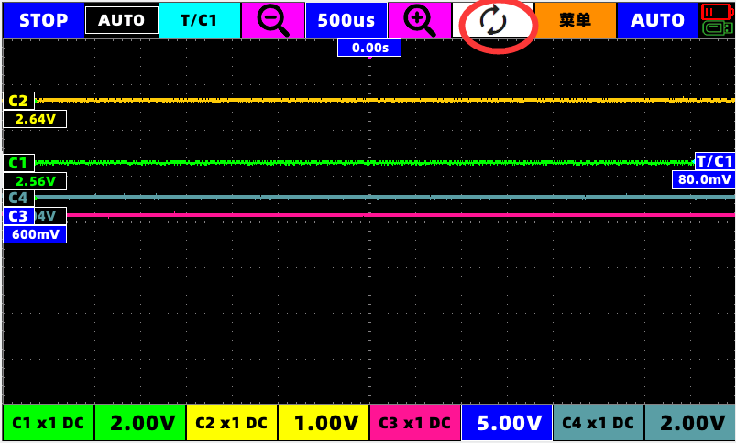
This switch key can switch between oscilloscope and signal generator with one key.

3.5menu:

3.5.1 Mathematical calculation
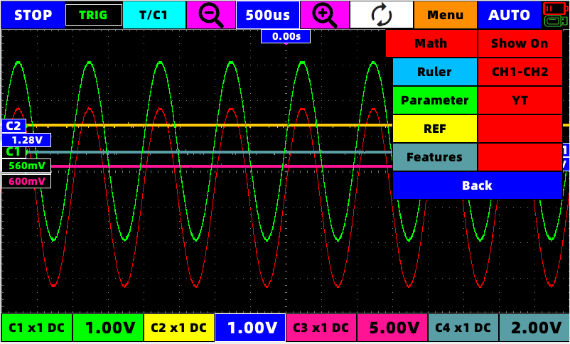
In this interface, you can choose to turn on or off the display of mathematical calculations, and you can choose YT or XY (Li Shayu) display mode
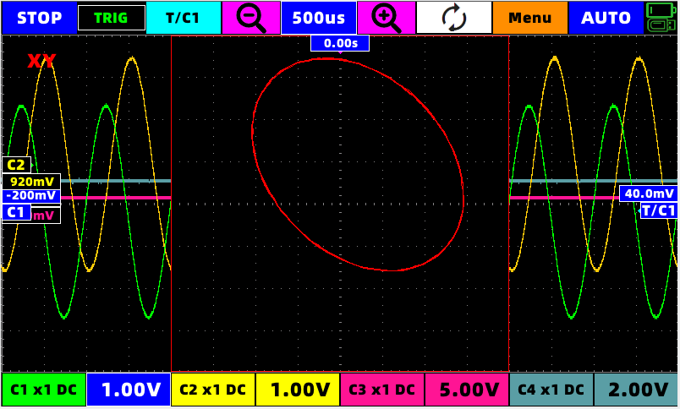

3.5.2 Ruler menu:
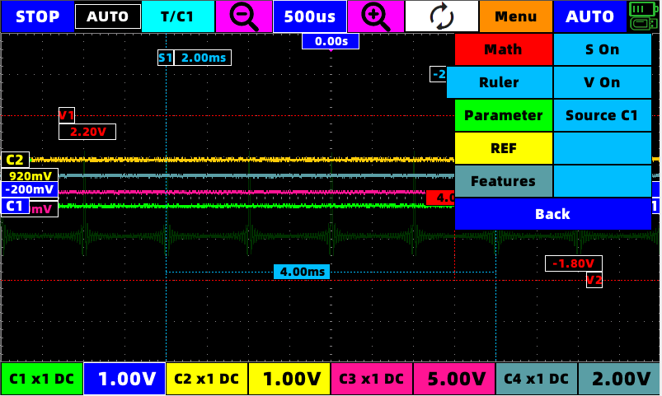
In this interface, you can open the horizontal and vertical rulers. As shown in the figure, the movements and selections marked follow the operation guide.
The signal source for simultaneous calculation can be C1 or C2

3.5.3 Parameter display:
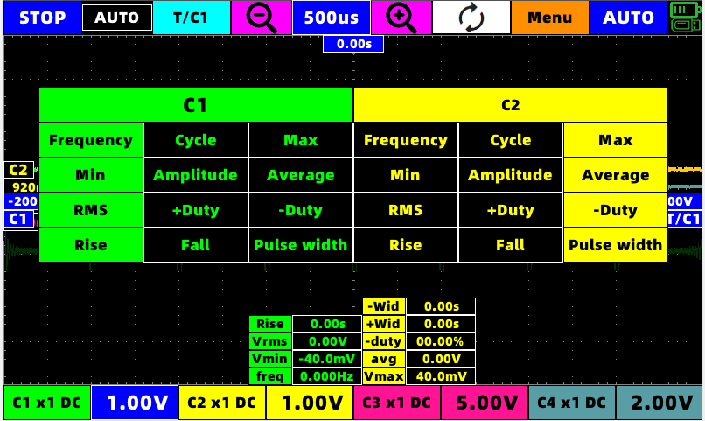
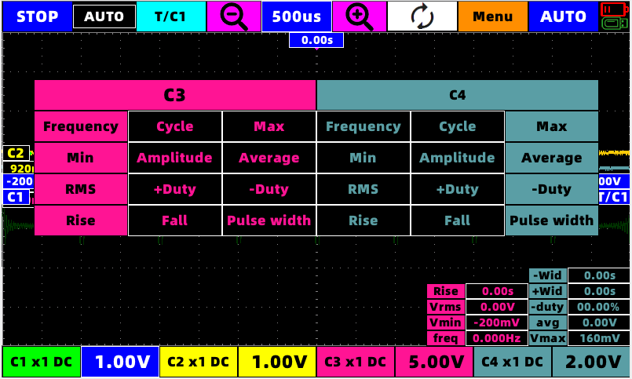
After opening the parameter display, you can select the parameter to be displayed by the corresponding channel, and the parameter will be displayed at the bottom of the screen.

3.5.4 Waveform comparison REF:

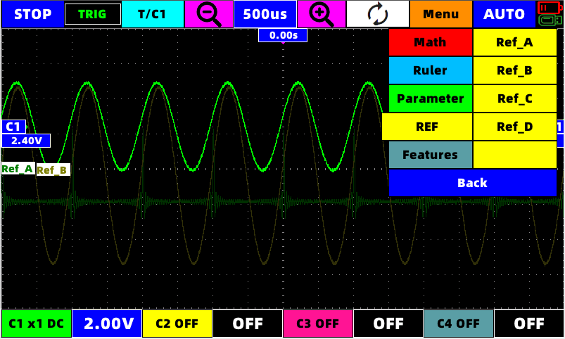
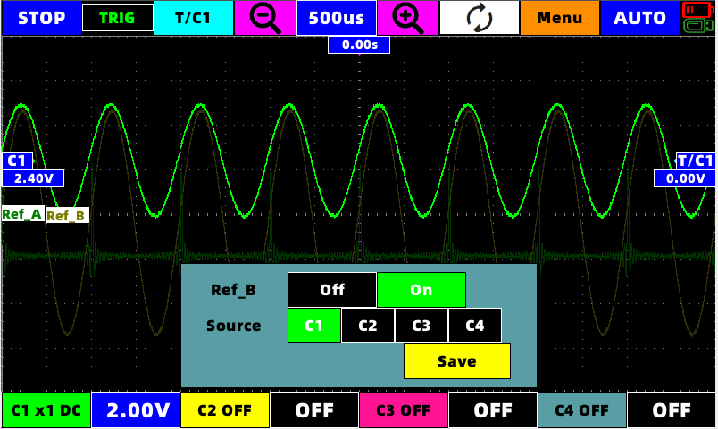

A total of four sets of real-time comparison waveforms Ref_A, Ref_B, Ref_C, Ref_D can be stored.
Each group can choose to save the source C1 or C2 or C3 or C4.

3.5.5 Function options:
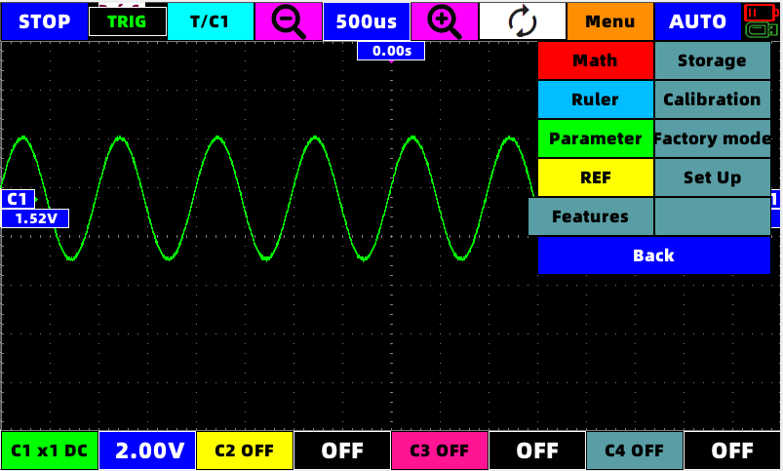

3.5.5.1 Store waveform
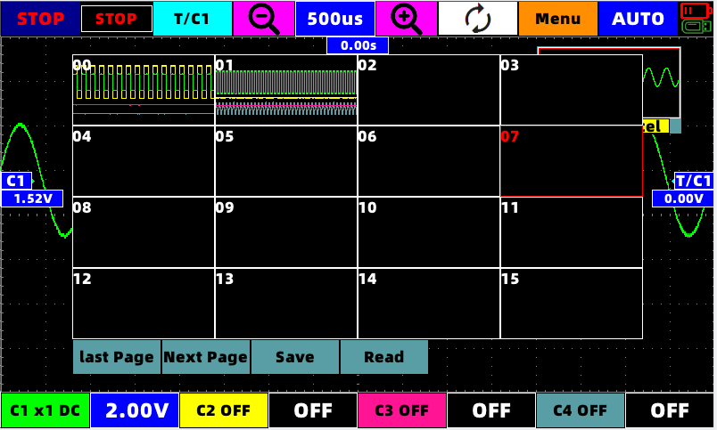
After clicking to store the waveform, the current waveform will automatically stop and enter the stop state.
In this interface, you can choose to save or read the waveform data of the previous waveform.
The read waveform data can be arbitrarily zoomed in and out to view the details, which is equivalent to the stop state.

3.5.5.2 Automatic calibration
This button will automatically calibrate the oscilloscope parameters.
Warning! Do not operate the device during automatic calibration, and do not connect any external connectors!!

3.5.5.3 Restore Factory
This button will return the machine's settings and some parameters to the factory state.

3.5.5.4 Set up
Equivalent to the settings of the main interface

3.5.5.5 return
Can return to the main interface under the oscilloscope interface.

3.6 C1 Channel menu
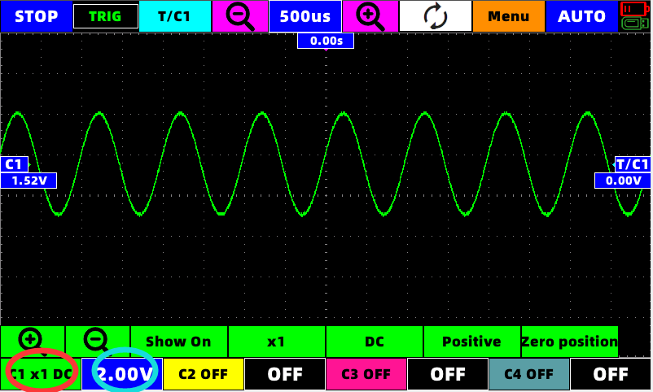
In this interface, you can zoom in and zoom out the waveform voltage range of C1,
You can choose whether to display the C1 waveform
Select the X multiple of the probe
Choose AC, DC
Select whether the display of C1 waveform is inverted
The vertical position of C1 can be returned to zero with one key

The red circle in the picture can select the C1 channel, and the basket ring can quickly open or close the C1 channel

3.7 C2 Channel menu
Reference C1 operation

3.8 C3 Channel menu
Reference C1 operation

3.9 C4 Channel menu
Reference C1 operation

Signal generator instructions:
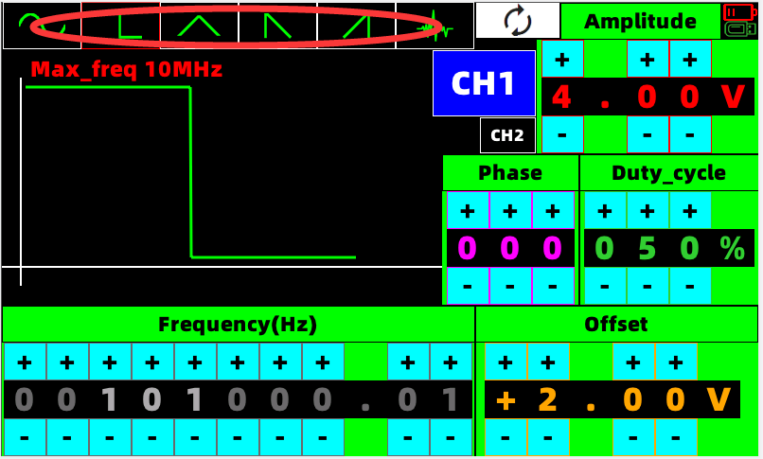

Through the corresponding +,-to modify the frequency, amplitude, offset, duty cycle and other signals, the waveform will be directly changed in real time.
The red circle area can select the waveform to be output.
As a dual-channel signal generator, both channels support phase change 0 °-360 °

Screenshot
After inserting the U disk, at any position on the screen, tap three fingers at the same time for 1 second after the buzzer sounds, a progress bar will appear, and the screenshot will be completed after the progress bar runs through the buzzer prompt.

6.Program upgrade
When the machine is turned on, insert the U disk containing the upgrade file, and then power on, the device will automatically enter the U disk upgrade program, click the upgrade button in the upgrade program, wait for the upgrade progress to 100% and automatically shut down.

Warning! Make sure that the battery level of the device is at the green level when upgrading!!

7.Oscilloscope parameters:

Number of channels 4
Maximum sampling rate Single channel1GSa/s
Dual channel 500MSa/s
Four channels 250MSa/s
bandwidth 100M
impedance 1MΩ 25pF
Storage depth Single channel Per channel32K
Dual channel Per channel32K
Four channels Per channel16K
Vertical resolution 8bit
Vertical gear 10mV-5V in the case of probe X1 (1, 2.5, 5 steps) Maximum measurement voltage X1(40V) X10(400V)
Use high-voltage probes, the maximum voltage is determined by the quality of the probe
Horizontal gear 5s - 10ns (1, 2.5 ,5 Stepping)
5s - 100ms Scan mode
Automatic measurement parameters 13
(Frequency,period,amplitude,maximum,minimum, average, effective value, duty cyclepositive,Duty cycle negative, positive pulse width, negative pulse width, rise time, fall time)
Trigger mode Automatic, normal, single
Trigger type Rising edge, falling edge
Autorange 50Hz - 30MHz
cursor Both vertical and horizontal support cursor measurement
Waveform record 32 groups (recording waveform supports zoom in and zoom out to view details)
Screenshot Support U disk screenshot
Mathematical calculation CH1+CH2,CH1-CH2,CH2-CH1
Display mode YT mode + XY mode (Li Shayu mode)
Automatic calibration stand by
Waveform comparison display Support 4 sets of comparison waveforms

display 7 inch capacitive touch screen
battery 8000mA large-capacity lithium-ion battery (full charge can be used for more than 6 hours)
Recharge Maximum support 5V2.1A DC charging. (The light reflects the charging status in real time)

8.Signal generator parameters:

Number of channels 2
Amplitude: 0 V - 8V (Minimum resolution 10mV)
Offset: 0V - ( + - 4V) (Minimum resolution 10mV)
Duty cycle: 0% - 100% (Minimum resolution 1%)
Phase: 0°- 360° (Minimum resolution 1°)
frequency:
Sine wave: 0.01Hz - 30Mhz (Minimum resolution 1/1000)
Fang Bo: 0.01Hz - 10Mhz (Minimum resolution 1/1000)
Other waveforms (triangular wave, sawtooth wave, ringing wave):
0.01Hz - 1Mhz (Minimum resolution 1/1000)

Accessories list:

Model | SMTO1004S
Oscilloscope | 1
Probes p6100 | 4
Bracket | 1
USB flash disk | 1
Chargers(5V 1A) | 1 EU/US（optional）
Data line(Type-C) | 1
Source line | 1
BNC to BNC connection line | 1
Probe calibration kit | 1
Box size | 1 （280x230x82mm）

